Biomechanical Models for Seating Design
by
Robert Hubbard, Ph.D., Professor
Department of Materials Science and Mechanics

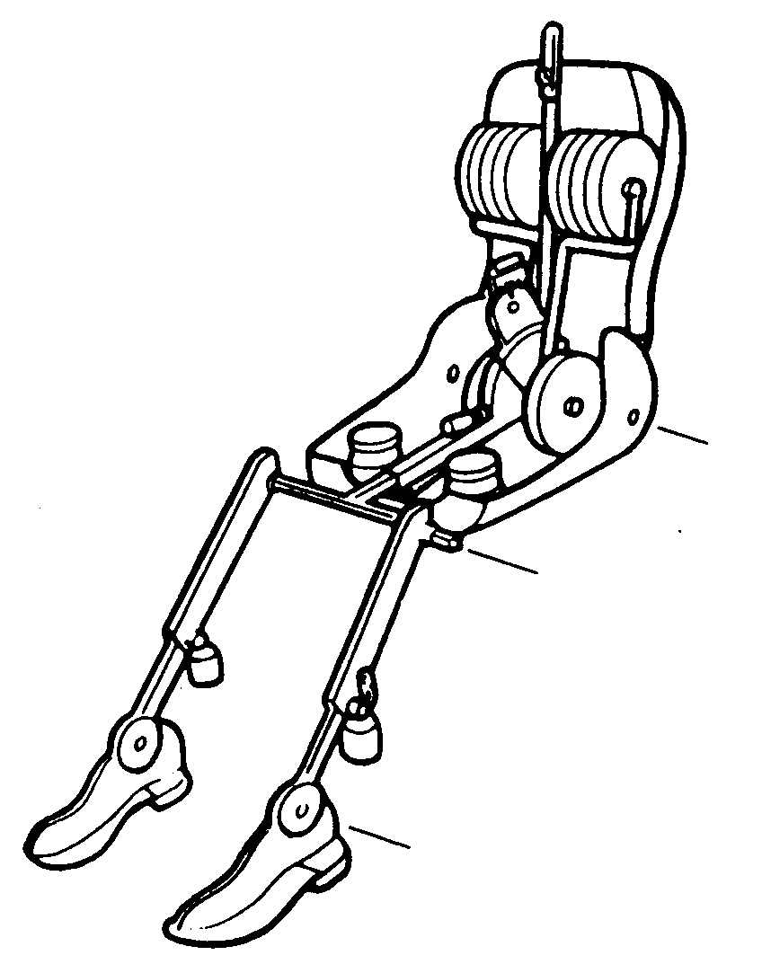Since the 1960’s, automotive seats have been designed and evaluated with tools and procedures described by the Society of Automotive Engineers (SAE). The SAE design template and manikin have a torso with a flat lower back shape and with a single joint at the hip joint (H-point). Similar tools have been used for office chairs.
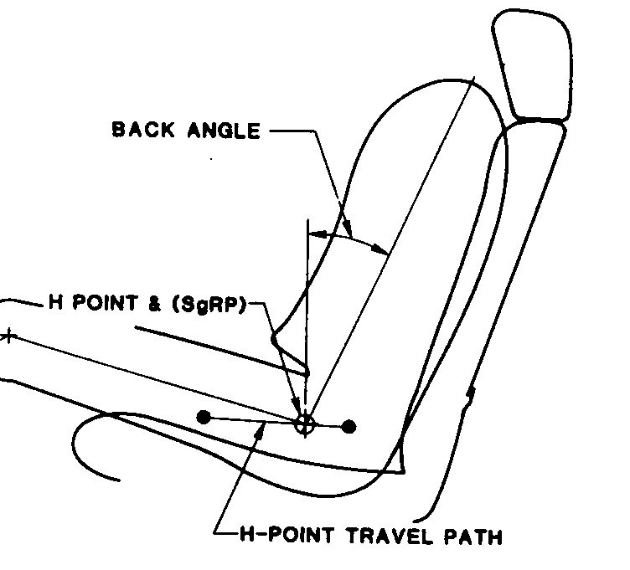
SAE drafting template SAE seating manikin

The JOHN biomechanical models have been developed at M.S.U. to provide a more anatomical representation of human shape and movement.
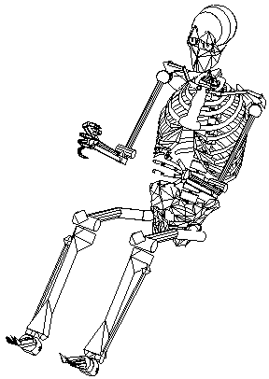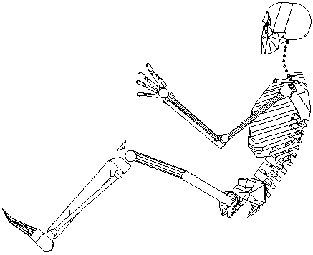
JOHN 3-D skeletal model.

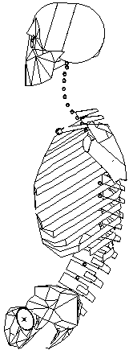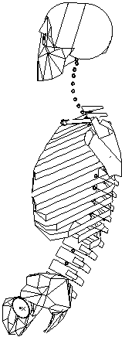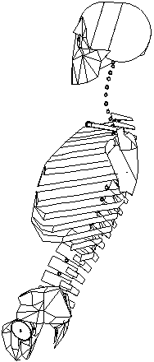
kyphosis straight lumbar lordosis
Torso posture and lumbar curvature.
The articulations of the JOHN torso (pelvic, lumbar, and thoracic) segments are coupled so that their relative positions are determined by a single parameter related to spinal curvature. This single spinal curvature parameter is a simplification to provide results that are close enough for seating design and to make the complex motions of human torsos to be manageable in product design.
The JOHN skeletal models are the basis for back contours that change with spinal articulation and can be scaled to represent different people.
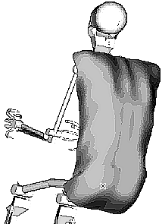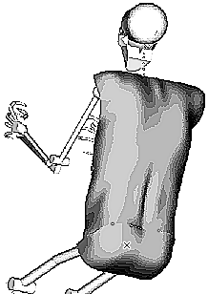
kyphosis lordosis
Back contours for mid-size male.

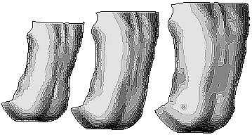
small female mid-size male large male
Back contours scaled for different people.

These biomechanical models have been used for seating designs in automotive and office markets. The models allow designers to understand the possibilities of human postures and movements so that they can design seats to support and move with people.
The coupled torso segment motions of these models have been adopted for the next SAE seat evaluation manikin. Methods have also been developed and used to measure human postures and movements in terms of these models so that measurements can be used for product evaluations that relate directly to biomechanical design objectives.

